**Project Title :- To supply leftover food to poor**

**1. Project Overview :-**

This project, titled "Salesforce-Based Solution for Supplying Leftover Food to Poor People," is designed to address the dual challenge of food waste and hunger. The initiative focuses on creating a robust platform using Salesforce to connect food donors—including restaurants, households, and event organizers—with NGOs and volunteers. By streamlining the process of collecting, tracking, and distributing surplus food, the project ensures that leftover food reaches underprivileged communities in an efficient and equitable manner.

Key aspects of the platform include real-time coordination between donors and distributors, enhanced tracking and reporting for accountability, and intuitive user interfaces to simplify operations for all stakeholders. The platform is a step towards reducing food waste, alleviating hunger, and building a more sustainable and socially responsible community. By leveraging Salesforce’s advanced features, the project aims to transform the way leftover food is managed and distributed, ensuring maximum impact with minimal resources.

**2. Objectives :-**

**Business Goals:**

* Minimize food wastage by efficiently collecting and redistributing surplus food.
* Create a real-time network of food donors, NGOs, and volunteers using Salesforce’s CRM capabilities.
* **Specific Outcomes:**
  + A centralized platform for food donation and distribution.
  + Improved transparency and accountability through real-time tracking and reporting.
  + Enhanced user experience with intuitive dashboards and mobile integrations.

**3. Salesforce Key Features and Concepts Utilized :**

* **Salesforce CRM:** To manage donor and NGO relationships.
* **Salesforce Lightning Experience:** For an intuitive and user-friendly interface.
* **Custom Objects:** To track food donations, collection schedules, and distribution details.
* **Workflows and Automation:** To notify NGOs and volunteers about food availability.
* **Mobile Accessibility:** To allow on-the-go access for volunteers and NGOs.
* **Reports and Dashboards:** For data-driven insights into donation trends and impact.

**Salesforce developer account creation**

**Creating Developer Account**   **:-**

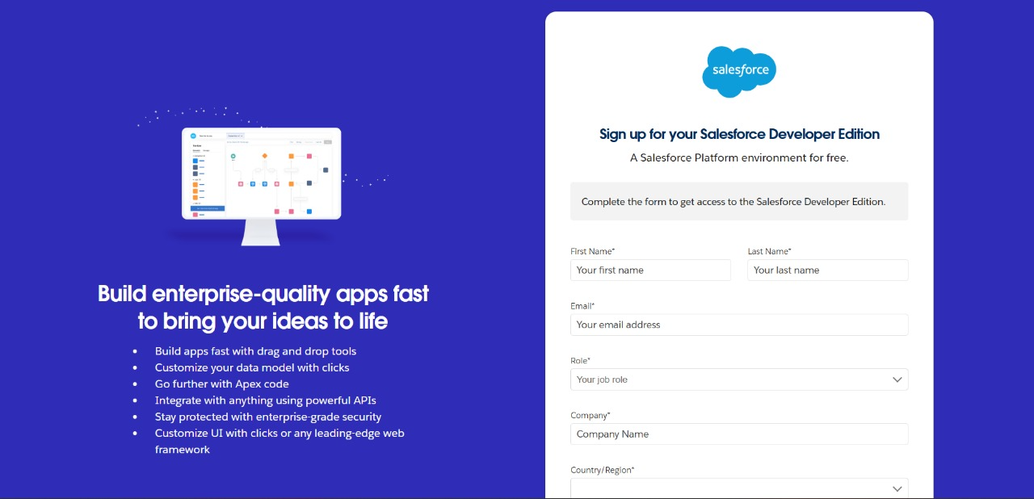

**Account Activation**   **:-** 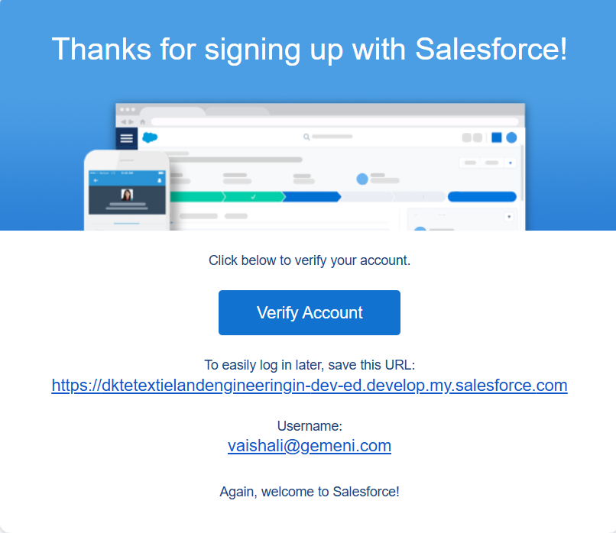

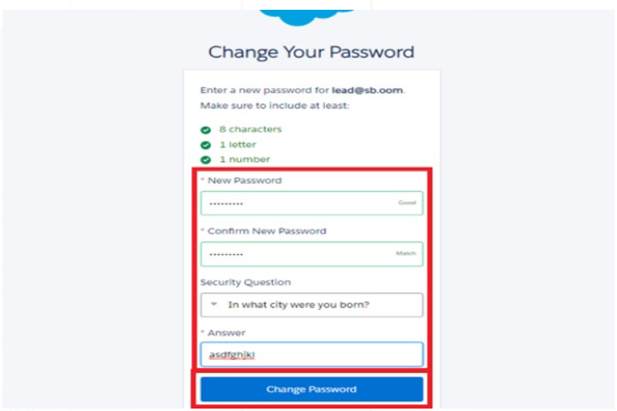

**Object**

**Create Venue Object**   **:-**

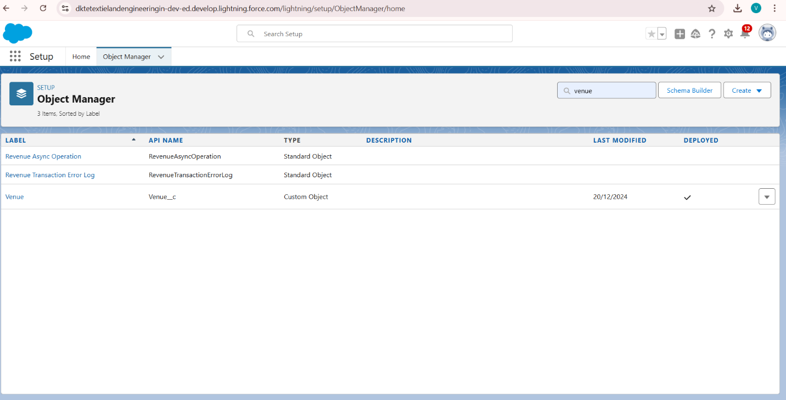

**Create Drop-Off Point Object**   **:-**

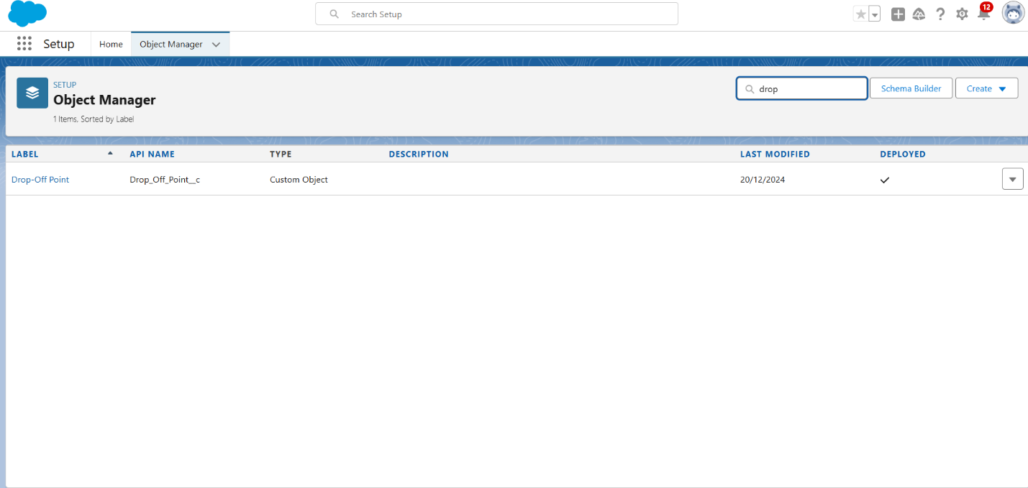

**Create Task Object**   **:-**

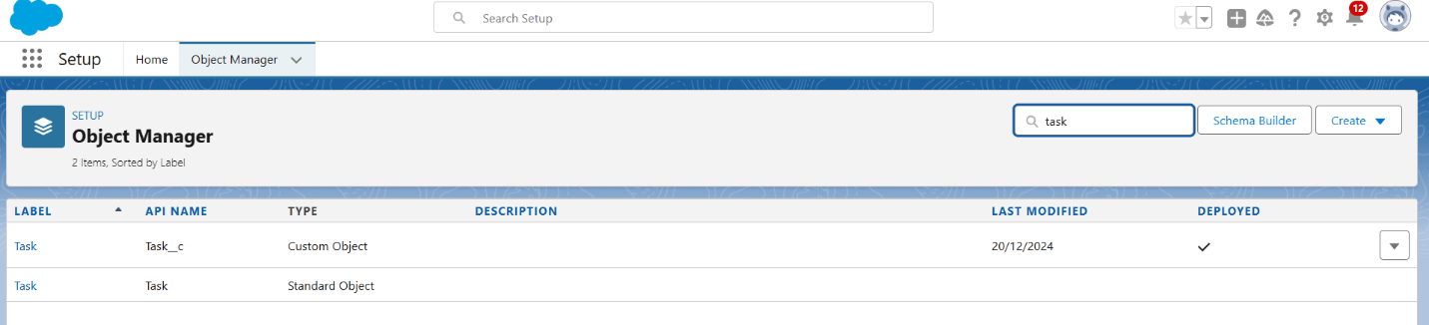

**Create Volunteer Object**   **:-**

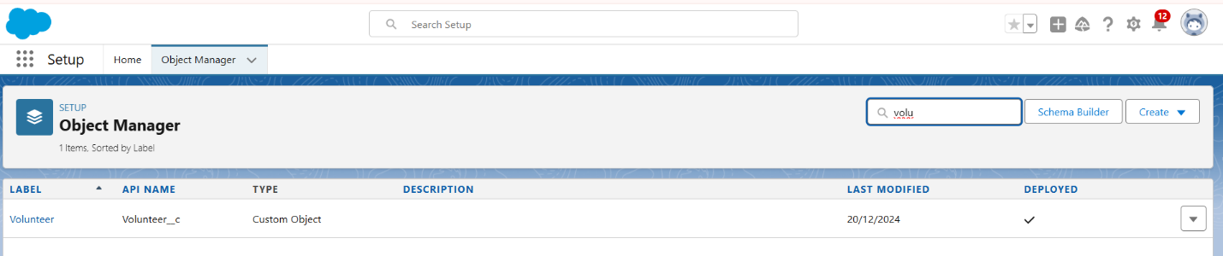

**Create Execution Details Object**   **:-**

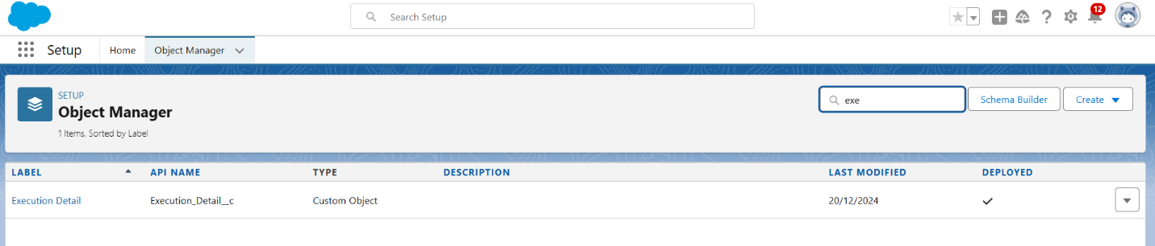

**Tabs**

**Creating a Custom Tab**  **:-**

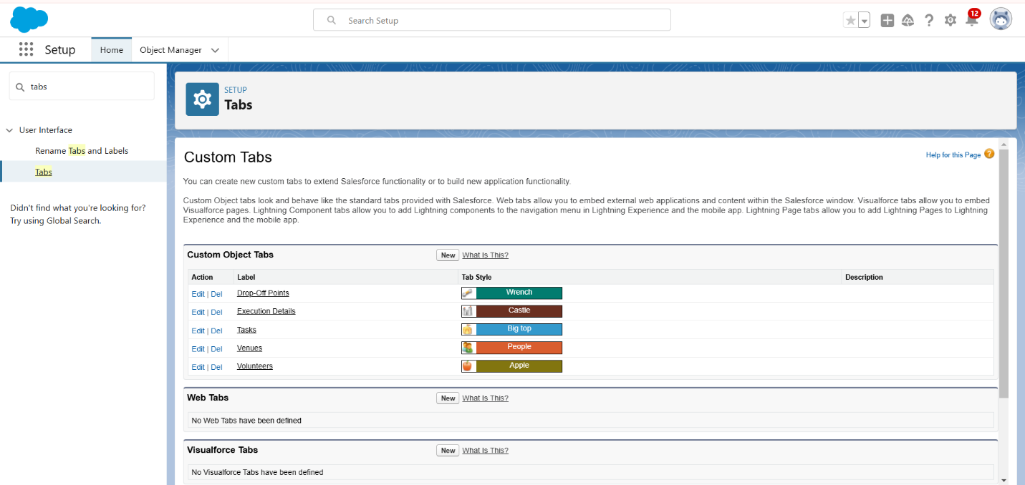

**The Lightning App**

**Create a Lightning App:-**

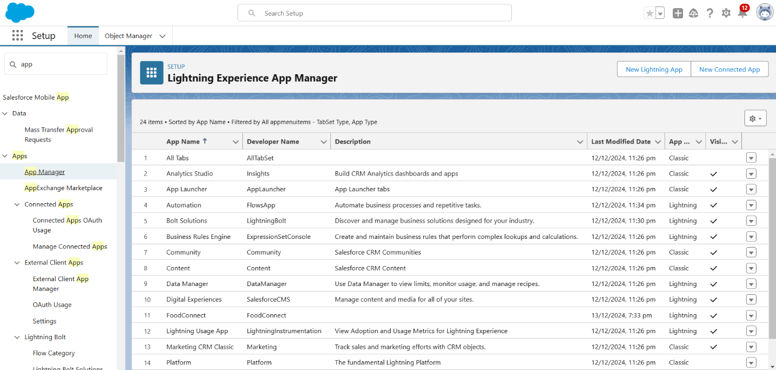

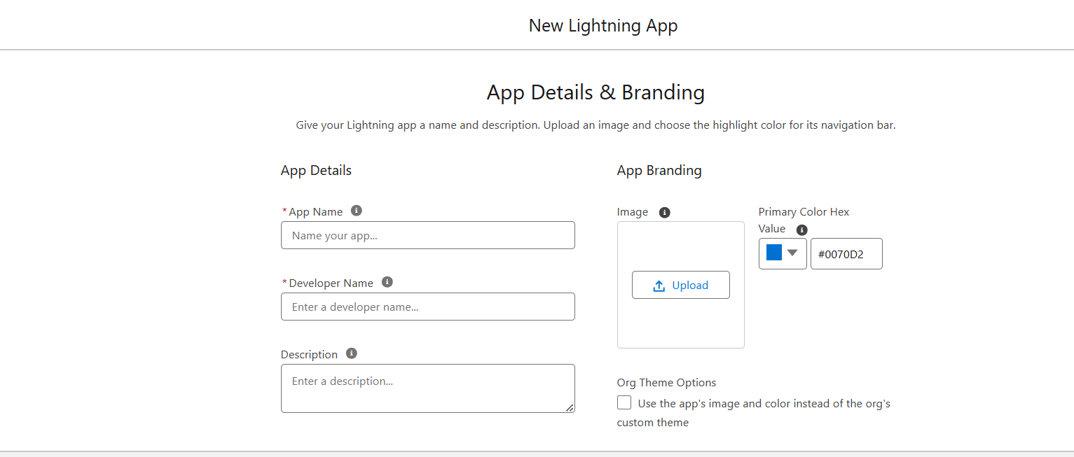

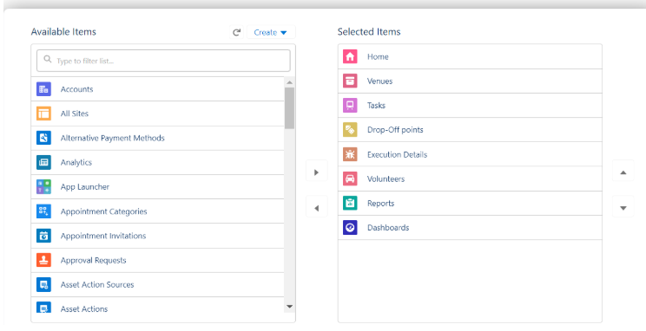

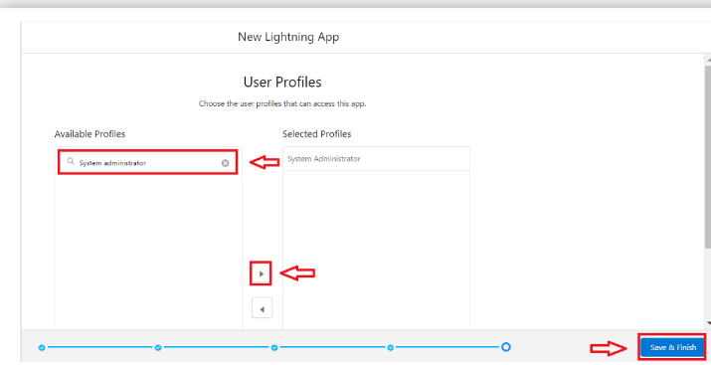

**Fields**

**Creation of Relationship fields in objects**   **:-**

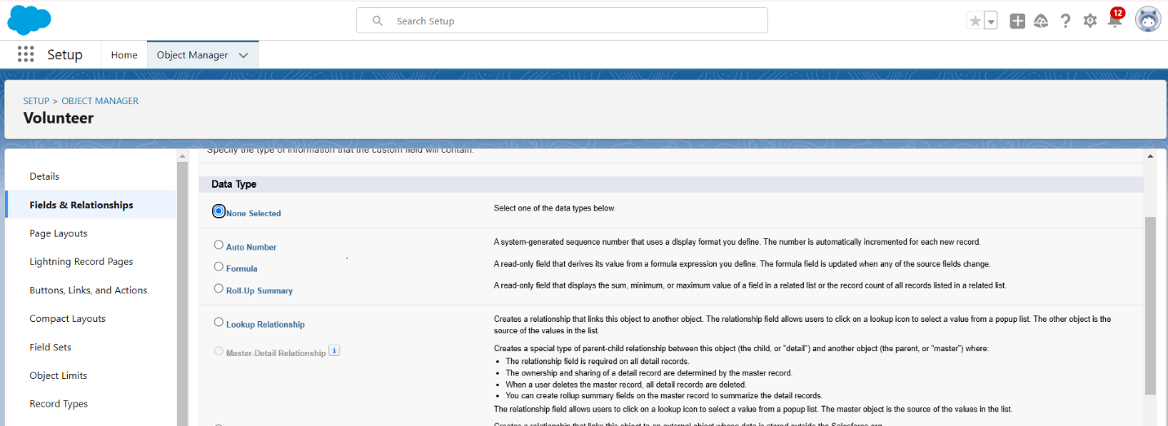

**Creation of fields for the Venue object**   **:-**

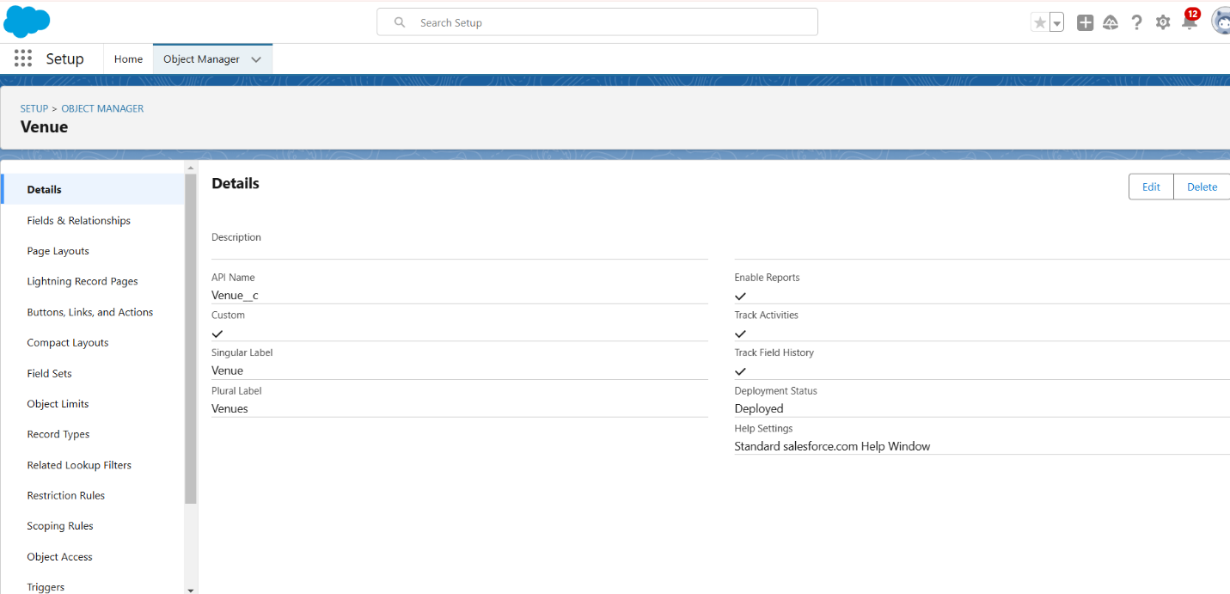

**4. Detailed Steps to Solution Design**

**Flow**s

**Create Flow to create a record in Venue object**   **:-**

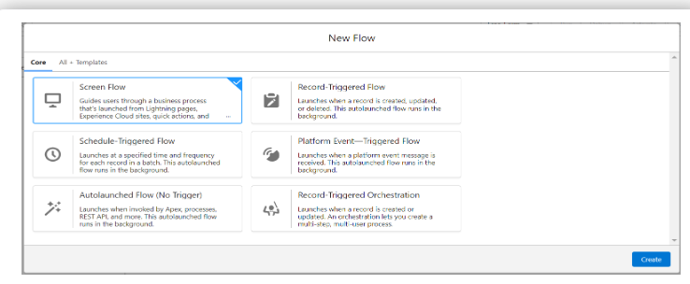

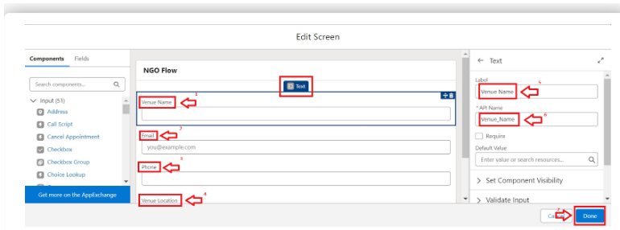

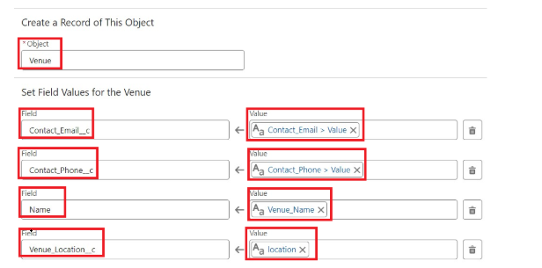

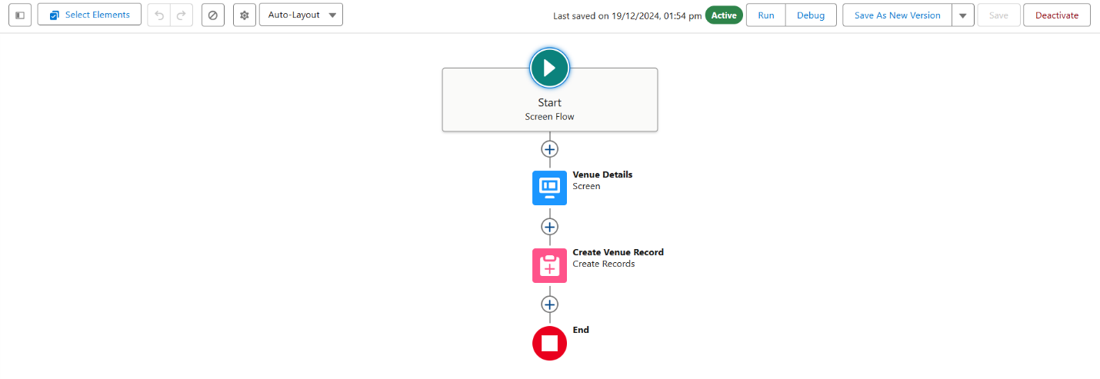

**5. Testing and Validation**

* **Unit Testing:**
  + Validate triggers and Apex classes to ensure smooth data processing.
* **User Interface Testing:**
  + Test all forms, workflows, and dashboards for usability and error handling.
* **Integration Testing:**
  + Ensure seamless integration with external mapping tools (e.g., Google Maps for location tracking).

**Trigger**

**Create a Trigger**   **:-**

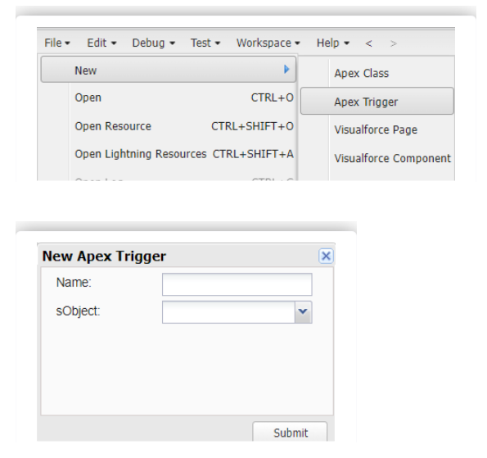

**Trigger Code**

**Code:**

trigger DropOffTrigger on Drop_Off_point__c (before insert) {

    for(Drop_Off_point__c Drop : Trigger.new){

        Drop.Distance__c = Drop.distance_calculation__c;

    }

}

**Creation of Users**

**Creation of User1**  **,same for user 2,3 :-**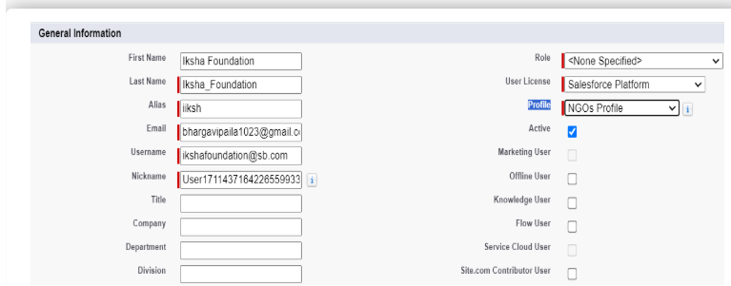

**Creation of Public Group 1,2,3 :-**

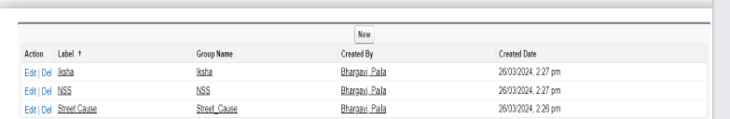

**6. Key Scenarios Addressed by Salesforce in the Implementation Project**

**Reports**

**Creation of Report on Venue with DropOff with Volunteer**   **:-**

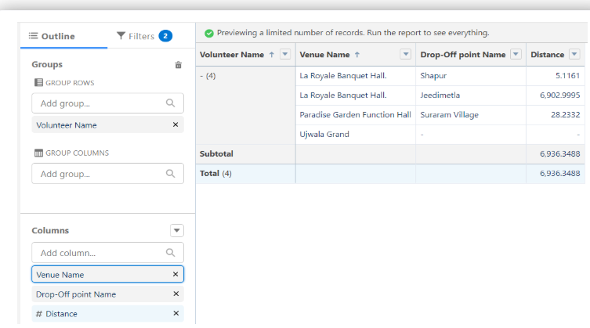

**Creation of Report on Volunteers with Execution Details and Tasks**

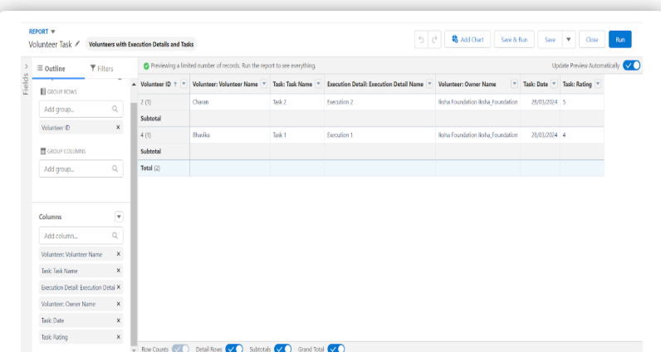

**Dashboards**

**Adding venue and Drop Off point Report to the Dashboard**   **:-**

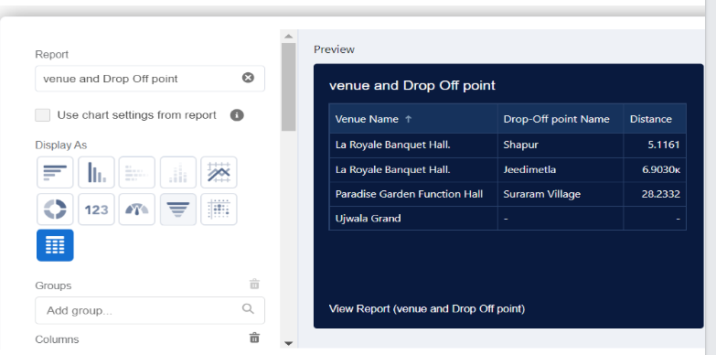

**Adding Volunteer Task Report to the Dashboard**   **:-**

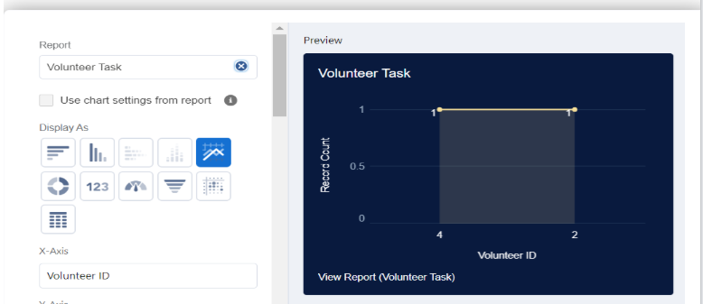

**Adding a Picture to the Dashboard (Optional)**   **:-**

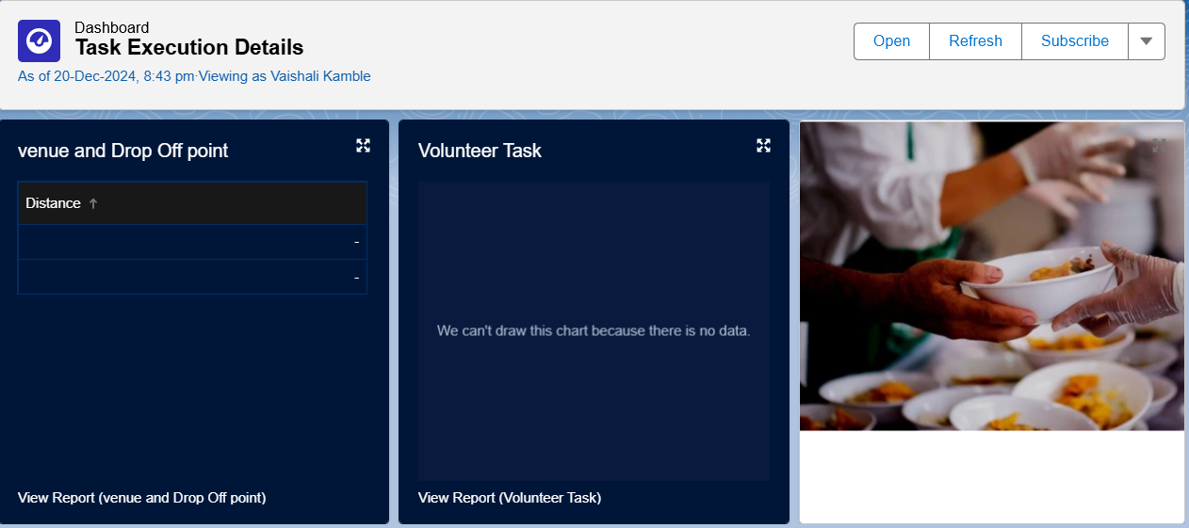

**Sharing Rules**

**Creation of sharing rules**   **:-**

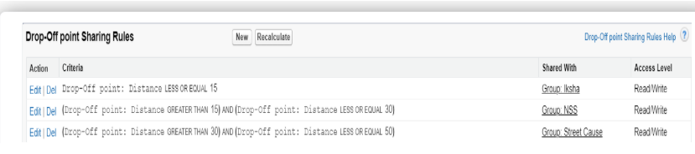

**Home Page**

**Creation of Home Page :-**

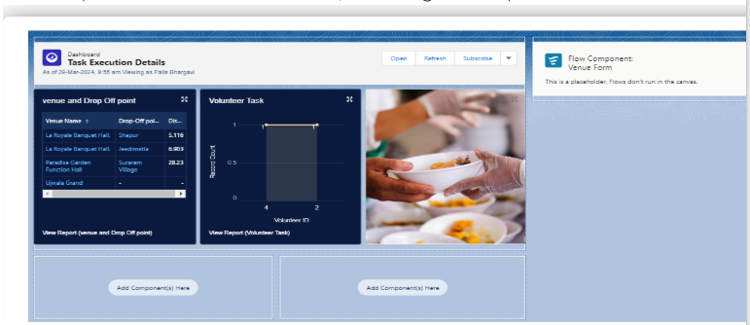

**Conclusion**

By leveraging the Salesforce platform, the project successfully established a streamlined and transparent system for managing surplus food donations. Through efficient coordination with volunteers and timely delivery to beneficiaries, the project effectively addressed food insecurity while maximizing the utilization of available resources.